Exercícios Hackaton

Grupo: Marcelo Camilo e Thales Alexandre  
  
Exercício 1:

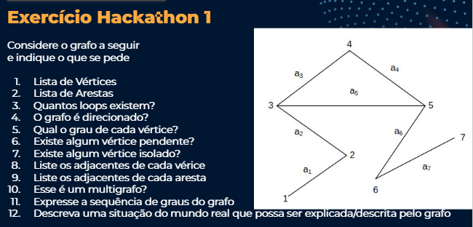

1 - (1,2,3,4,5,6,7)

2 - fa1,a2,a3,a4,a5,a6,a7]

3 - 0

4 - Não

5 - (1: 1,2: 2,3: 3,4: 2,5: 3,6: 2,7: 1)

6 - Sim: 2

7- Não

8 - (1: (2),2: (1,2),3: (2,3,5),4: (3,5),5: (3,4,6),6: (5,7),7: (6])

9 - (al:(a2), a2:(a1,a3,a5), a3:fa2,a4), a4:(a3,a5,a6), a5:(a2,33,a4,a6),a6:(a5,a7),a7:(a6]]

10 - Não

11 - (3: 3,4: 3,2: 2,4: 2,6: 2,1: 1,7: 1): 2 com grau 3, 2 com grau 1, restante grau 2

12 - Rede social: cada vértice seria um usuário e as arestas seriam as conexões / amizades entre eles

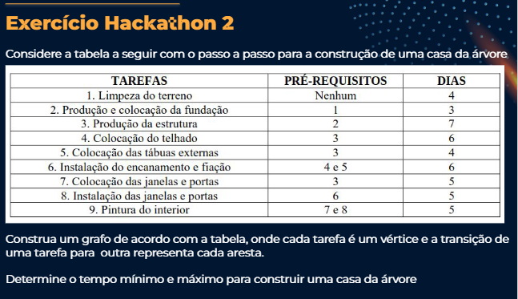

|  |  |
| --- | --- |
| Tempo mais curto: 35 dias | Tempo mais longo: 45 |
|  |  |

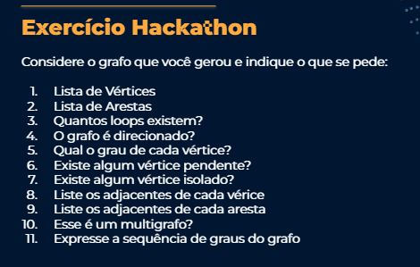

1 – {1,2,3,4,5,6,7,8,9}

2 – { 1->2, 2->3, 3->7, 3->5, 3->4, 4->5, 5->4, 4->6, 5->6, 6->8, 8->7, 7->8, 7->9, 8->9}

3 – 0

4 – Sim

5 -

|  |  |  |  |  |  |  |  |  |  |
| --- | --- | --- | --- | --- | --- | --- | --- | --- | --- |
| **Grau\Vértice** | **1** | **2** | **3** | **4** | **5** | **6** | **7** | **8** | **9** |
| **Entrada** | 0 | 1 | 1 | 2 | 2 | 2 | 2 | 2 | 2 |
| **Saída** | 1 | 1 | 3 | 2 | 2 | 1 | 2 | 2 | 0 |

6 – Sim: 1

7 – Não

8 –

|  |  |
| --- | --- |
| Vértice | Adjacentes |
| 1 | 2 |
| 2 | 1, 3 |
| 3 | 2, 7, 5, 4 |
| 4 | 3, 5, 6 |
| 5 | 3, 4, 6 |
| 6 | 4, 5, 8 |
| 7 | 3, 8, 9 |
| 8 | 6, 7, 9 |
| 9 | 7, 8 |

9 –

|  |  |
| --- | --- |
| Aresta | Adjacentes |
| 1->2 | 2->3 |
| 2->3 | 1->2, 3->7, 3->5, 3->4 |
| 3->4 | 2->3, 3->7, 3->5, 4->5, 5->4, 4->6 |
| 3->5 | 2->3, 3->7, 3->4, 4->5, 5->4, 4->6 |
| 3->7 | 2->3, 3->4, 3->5, 7->8, 8->7, 7->9 |
| 4->5 | 5->4, 3->4, 3->5, 4->6, 5->6 |
| 5->4 | 4->5, 3->4, 3->5, 4->6, 5->6 |
| 5->6 | 3->5, 4->5, 5->4, 4->6, 6->8 |
| 4->6 | 3->5, 4->5, 5->4, 5->6, 6->8 |
| 6->8 | 4->6, 5->6, 7->8, 8->7, 8->9 |
| 8->7 | 3->7, 7->9, 7->8, 8->9, 6->8 |
| 7->8 | 3->7, 7->9, 8->7, 8->9, 6->8 |
| 7->9 | 3->7, 7->8, 8->7, 8->9 |
| 8->9 | 3->7, 7->8, 8->7, 7->9 |

10 – Não

11 – Entrada: {2, 2, 2, 2, 2, 2, 1, 1, 0}, Saída: {3, 2, 2, 2, 2, 1, 1, 1, 0}